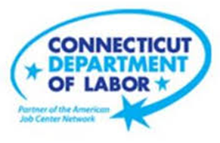

**NEW WEEKLY JOB POSTINGS FROM   
HELP WANTED ONLINE  
Office of Research**

**Week Ending June 5th, 2021 – Total Ads Down Over Four Weeks From Early May Series High**

WETHERSFIELD, June 11th, 2021 – During the week ending June 5th, 2021, there were 6,390 new postings, down 6% from a week ago and down 26% from four weeks ago. The most recent week continues declines from the series high four weeks ago during the week ending May 8th. A Majority of sectors had over the week declines, with some of the largest occurring in Health Care & Social Assistance (-289 new ads), Accommodation & Food Services (-109 new ads), and Manufacturing (-31 new ads). Sectors that added Jobs over the week include Finance & Insurance (+95 new ads), Admin. & Support (+29 new ads), and Educational Services (+21 new ads). Employers that had the largest ad change over the week include gains at the State of Connecticut (+74 new ads), UnitedHealth Group (+58 new ads), and Deloitte (+44 new ads), and losses at Hartford Healthcare (-185 new ads), Atria Senior Living (-47 new ads), and Restaurant Depot (-45 new ads).  
  
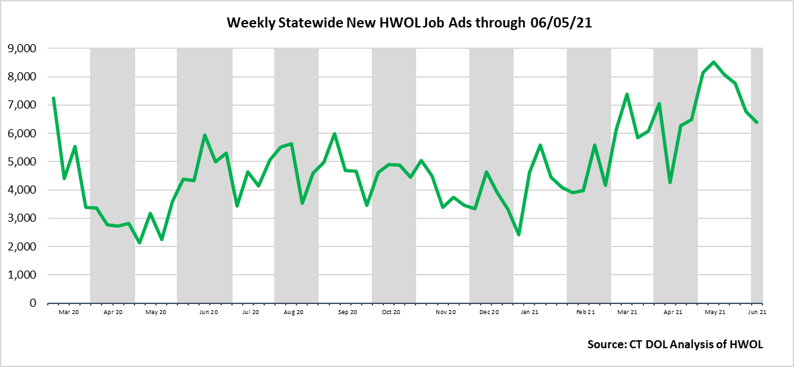

**Industries** with the most new postings include Health Care & Social Assistance, Retail Trade, and Finance & Insurance

**Occupations** with the most new postings include Registered Nurses, Laborers and Freight, Stock & Material Movers, and Retail Salespersons.

**Employers** with the most new postings include Amazon, State of Connecticut, and UnitedHealth Group.

**The three industries with the most new job postings where**

* **Health Care & Social Assistance** (1,027 new postings, -22% over the week)
* **Retail Trade** (936 new postings, -0.2% over the week)
* **Finance & Insurance** (558 new postings, +21% over the week)

  
 Twelve sectors had job posting decreases over the week, one was unchanged, and eight had increases. The 12 decreasing industries fell by a combined 564 new ads over the week. About seventy percent of that decline occurred in two sectors, Health Care & Social Assistance (-289 new ads or -22%) and Accommodation & Food Services (-109 new ads or -22%). The 8 increasing industries grew over the week by a combined 180 new ads with most of the increase occurring in Finance & Insurance (+95 new ads). Over four weeks, 18 sectors had new ad decreases and 3 had increases. The largest of each occurred in Health Care & Social Assistance (-892 new ads) and Retail Trade (+46 new ads).

For more information on total job ads by industry for Connecticut and its labor market areas, see the monthly report available here: <https://www1.ctdol.state.ct.us/lmi/hwol.asp>

**New Job Postings by Occupation**



**The occupations with the most new postings were:**

* Registered Nurses (246 new postings, -15% over the week)
* Laborers and Freight, Stock, and Material Movers (181 new postings, -20% over the week)
* Retail Salesperson (177 new ads, +11% over the week)

**Employers with the Most New Job Postings** 

Employers with the most new job postings during the week ending June 5thth were mostly in Finance & Insurance, Retail Trade, and Healthcare. The 25 employers shown above account for 21 percent of all new ads. Of the top 25 employers, 20 had over the week increases and 5 had decreases. Among increasing employers, the largest occurred at the State of Connecticut (+74 new ads) and the largest decrease occurred at Hartford Healthcare (-185). Over four weeks, the largest employer increase and decrease occurred at Amazon (+151) and Hartford Healthcare (-345) respectively.  
 **Covid-19 and Weekly New Job Postings**  
HWOL report includes new weekly job postings to illustrate how Covid-19 has impacted Connecticut in the short term and highlight recent job postings in the weeks since the virus disrupted both the economy and labor markets.  
  
**What is HWOL?**The **Conference Board Help Wanted Online**® Data Series (HWOL) measures the number of new, first-time Online job postings and jobs reposted from the previous month for over 16,000 Internet job boards, corporate boards and smaller job sites that serve niche markets and smaller geographic areas. To view more HWOL data, go to: [**https://www1.ctdol.state.ct.us/lmi/pubs/HWOL2020.pdf**](https://www1.ctdol.state.ct.us/lmi/pubs/HWOL2020.pdf)